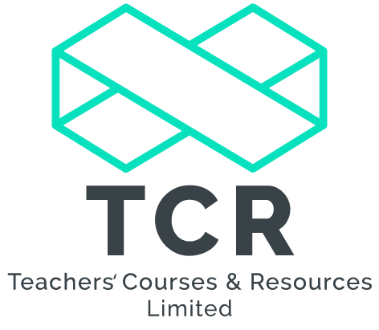

Linking Spelling to Phonics in Key Stage 2
Course Information
Date: 11th February 2020
Venue: Moat Hall Primary School, John’s Lane, Great Wyrley, WS6 6BX
Time: 13:00-16:00
Cost: £80
Course Leader: Claire Hubbard
Course Overview
This course is designed to support Key Stage Two staff with the teaching of spellings using phonics as one of the main strategies, as outlined in the DFE Letters and Sounds document used by many schools in Key Stage One.
Many Key Stage Two teachers lack confidence in the application of phonics, yet this is key to bridging the gap between Key Stage One and Two, to developing an understanding of spelling and why words are written as they are.
This course supports staff in the teaching and learning of spellings whilst using phonics in everyday writing. It explores the vocabulary used in phonics; how to articulate the sounds; the four parts to a daily spelling session; games, activities and investigations; the many and varied ways to spell different sounds and making the correct choices (GPCs); and how to help children understand the mechanics of spelling.
It also determines the pace of the teaching and coverage of the criteria; makes explicit links to texts and the National Curriculum as well as improving pupil’s confidence. Electronic resources will be available to anyone who attends the course after completion. Guidance will also be given on the statutory Key Stage Two Spelling, Punctuation and Grammar test.
Course Content
- Phonics in KS1 and KS2
- The 6 Phases of Phonics and beyond
- The importance of phonics when teaching spelling
- The application of phonics when teaching spelling
- Using Phonic Charts to improve spelling
- Spelling expectations in KS2
- Using Spelling investigations
- Assessment and Tracking
Bookings can be made at www.teachcr.com and further course information is available by contacting enquiries@teachcr.com

