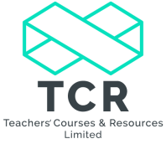

Phonics Phases 1-6 for Teaching Assistants
Course Information
Date: 8th January 2020
Venue: Ravensmead Primary School, Chapel Street, Bignall End, Stoke-on-Trent, ST7 8QD
Time: 9:00am -12:00pm
Cost: £80
Course Leader: Claire Hubbard
Course Overview
The course is designed to support subject leaders, EYFS and KS1 teachers, HLTAs and teaching assistants with the teaching of phonics in line with the Letters and Sounds document used by many schools. The training will support staff in the teaching of the daily phonics lesson along with the application of the use of phonics and spellings in everyday writing.
Course Content
- vocabulary used in phonics
- how to articulate the sounds
- the four parts to the daily phonics session
- planning formats
- prompts for observing phonics
- assessment and the characteristics of a good phonics session.
- using tracking sheets
- phase 6 coverage
- using a phoneme frame
- games and activities bank
- using desk charts from R-Y6
- developing a phonic glossary
- useful websites
The training will make explicit links to texts and the National Curriculum as well as improving pupil’s confidence. Guidance will also be given on the Year One Phonics Screening test and the Key Stage One Spelling, Punctuation and Grammar test.
Bookings can be made by contacting www.teachcr.com or enquiries@teachcr.com

